<zsight> zsight tech user guide (ugu)



Document ID | DigDev_ZSight_User_Guide_(UGU)_v1.0
Product | ZSight
Environment | QA
Confidentiality Level | Internal / Restricted

Contents
1 DOCUMENT INFORMATION 4
1.1 Validation 4
1.2 Document Distribution 4
1.3 Version Control 4
2 PREFACE 5
2.1 About this document 5
2.2 Related documents 5
2.3 Who should read this document 5
2.4 Terminology 5
2.5 Conventions Used 5
3 USER GUIDE 7
3.1 Overview 7
3.2 User Interface 7
3.2.1 Login Page 7
3.2.2 Dashboard 8
3.2.3 Containers 8
3.2.4 Daily Feed 14
3.2.5 Notifications 14
3.2.6 Customers 16
3.2.7 Vendors 17
3.2.8 Device Management 17
3.2.9 Settings 18
3.3 Admin Options 21
3.3.2 Admin Dashboard 21
3.3.3 Accounts 21
3.3.4 Customers 22
3.3.5 Users 23
3.3.6 Contracts 25
3.3.7 Subscriptions 25
3.3.8 Inventory 25
3.3.9 Installers 25
3.3.10 Reports 26
3.3.11 Audit Trail 26
3.4 Overall System Functionalities 26
3.4.1 Filter 26
3.4.2 Search 27
3.4.3 Export 27
3.4.4 Show/Hide Columns 27
3.5 User Roles 28
4 WORKING PROCEDURES 29
4.1 Working Procedure 1 29
4.2 Working Procedure 2 29
4.3 Working Procedure 3 29
5 APPROVAL SIGNATURES 30

DOCUMENT INFORMATION

Validation
Name |  | Role | Date (dd/mm/aa)
Issued by | Oscar Rondon | Technical Writer | 30/04/2026
Verified by
Approved by | Anthony Bures | Digital Development Manager | 20/04/2026

Document Distribution
Normal | Role
Oscar Rondon | Technical Writer
Anthony Bures | Digital Development Manager
Ezequiel Garcia | ZSight Developer
Gabriela Romero | QA Engineer

Version Control
Version | Date | Author | Description of changes
1.0 | 30/04/2026 | Oscar Rondon | 1st version of the ZSight user guide (UGU) document

PREFACE

About this document
This User Guide (UGU) provides an overview of the ZSight application, including its interface, main features, and operational capabilities. It is intended to help users understand how to navigate the platform and use its functionalities to monitor and manage smart trash containers. The document includes descriptions of key modules, user interactions, and supporting workflows.

Related documents
All documents or elements used for reference are presented in the following table:
Title | Reference | Author | Version

Who should read this document
This document is intended for ZTERS team members, customers, and service providers who interact with the ZSight application. It is particularly useful for users responsible for monitoring container status, reviewing operational data, and coordinating service activities. New users can use this guide as a reference to understand the system, while experienced users can use it for feature clarification.

Terminology
Term Used | Description
ZSight | ZTERS application used to monitor and manage smart trash containers with camera-based insights.
Container | A physical waste container equipped with a camera to track fullness and activity.
Fullness Level | Measurement indicating how full a container is, based on image analysis.
Customer | Organization or client using ZSight to monitor their containers (e.g., McDonald's).
Vendor | Service provider responsible for collecting or servicing containers.
Device | Camera or hardware installed inside a container to capture images and data.
Daily Feed | Visual timeline of images and events captured for containers.
Monitoring | System capability to track container status, activity, and operational events.
Admin User | User with elevated permissions to manage accounts, configurations, and system data.

Conventions Used
The following structures are used as recommendations.
Info: Supplementary Information

Tip: A recommendation or useful advice

Warning: A warning or important notice

Note: A notice.

USER GUIDE

Overview
ZSight is a management application designed to monitor and manage smart cameras installed in residue containers. It allows customers to visualize the fill level of each container, review captured images, and track container status in real time. The system provides operational visibility to support timely collection and service planning. ZSight also facilitates collaboration between customers and service providers by centralizing container data in a single platform.

User Interface
The user interface starts with the ZSight logging page, and then multiple options show up for customers to keep track of their containers.

Login Page
The Login Page allows users to securely access the ZSight application by entering their registered email address and password.
Tip: Access to the application is restricted and requires connection through the ZTERS VPN.

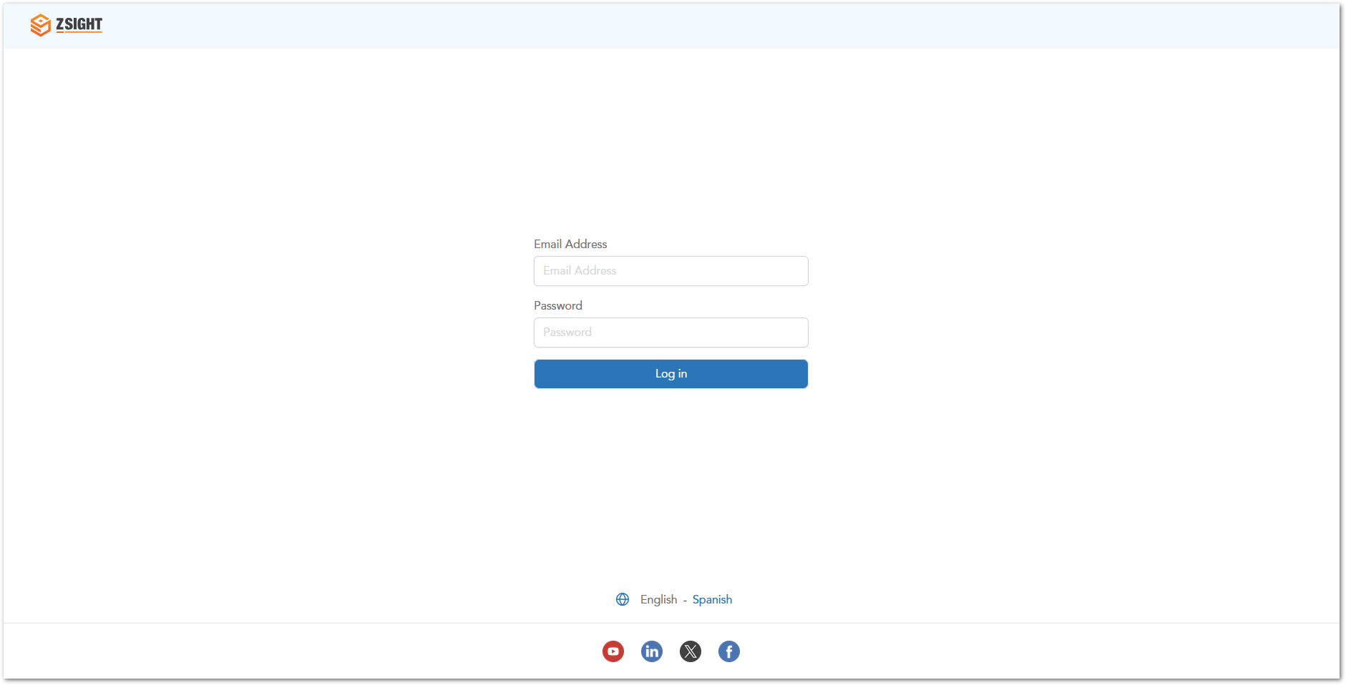

Dashboard
The Dashboard provides a high-level overview of container activity and key operational metrics. It allows users to quickly understand the overall status of their containers and identify areas that require attention.
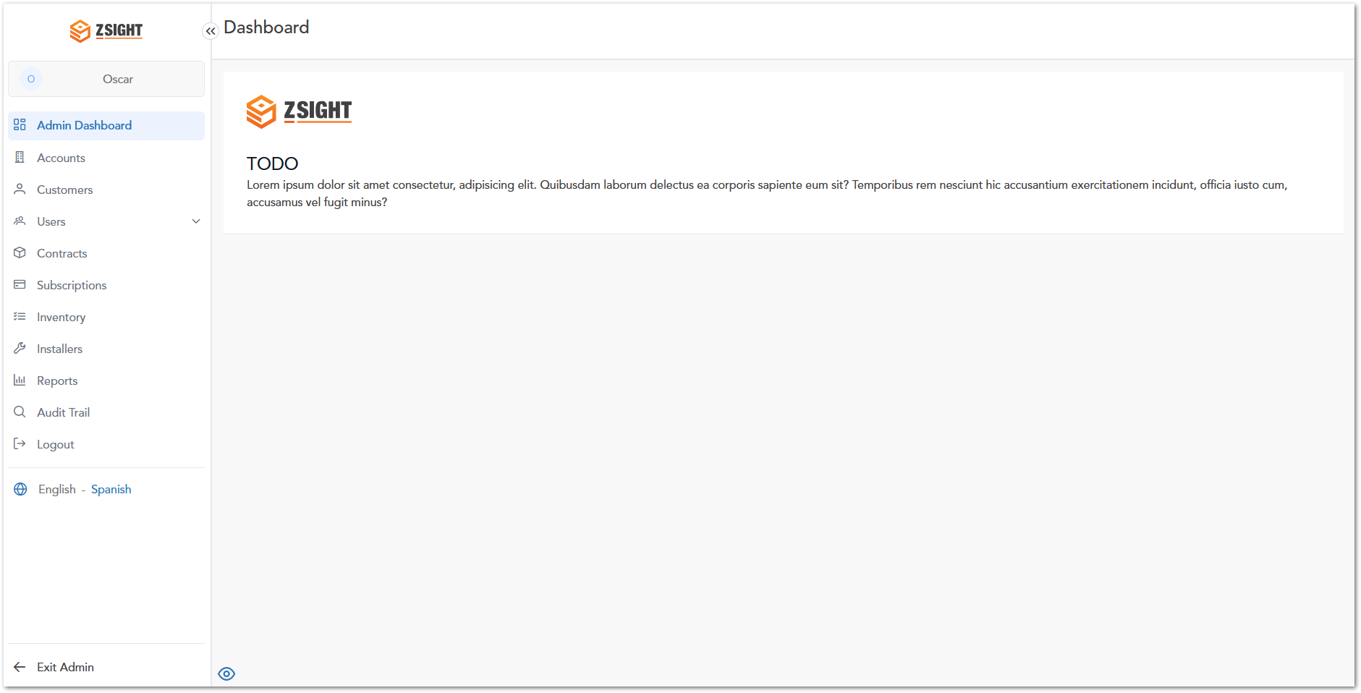

Containers
The Containers module allows users to view and monitor all registered containers within the system. It provides real-time visibility into container status, including fullness levels, recent activity, and service history. Users can access detailed information for each container, enabling better decision-making for waste collection and operational planning.

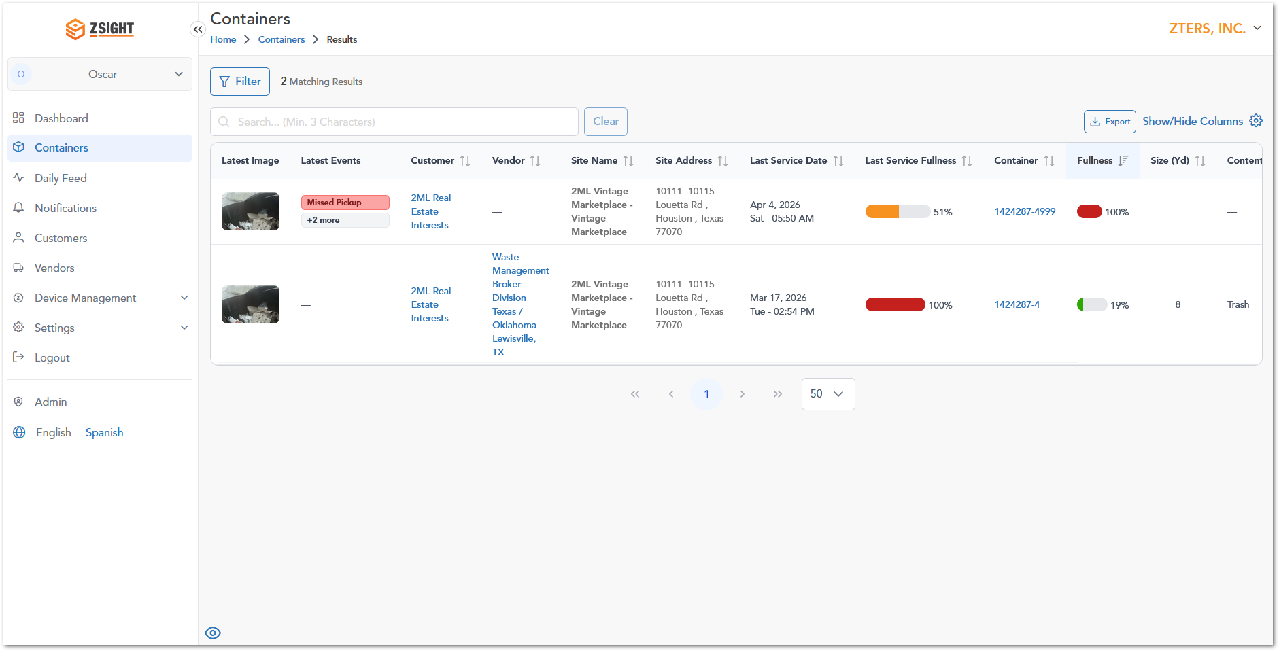

Containers Column Description
Name | Preview | Description
Latest Image |  | Displays the most recent image captured inside the container.
Latest Events | 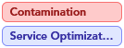  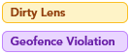  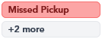 | The Latest Events column displays recent activity or alerts related to the container. These events help users quickly identify issues, operational updates, or system notifications.  Event Types:  - Contamination: Non-allowed or mixed waste detected inside the container.  - Service Optimization: Suggests adjustments to service timing or frequency.  - Tilted Camera: Camera is not properly positioned.  - Dirty Lens: Camera lens may be obstructed or dirty.  - Geofence Violation: Container has moved outside its designated location.  - Device Offline: Device is not transmitting data.  - Missed Pickup: Scheduled pickup did not occur.  - High Temperature: Abnormal temperature detected inside the container.  - Pickup Detected: A pickup service has been successfully completed.  - Installation: Device or container has been installed.  - +X more: Additional events exist but are not displayed in the preview.
Customer | Koepp-Hahn | Customer associated with the container.
Vendor | Johns-Gislason | Service provider responsible for servicing the container.
Site Name / Address | 84866 Abel Creek, Hahnmouth, MS 98157 | Physical location where the container is installed.
Last Service Date | Mar 19, 2026Thu - 01:42 PM | Date and time of the most recent service performed on the container.
Last Service Fullness |  | Fullness level recorded during the last service.
Container | 931-White7 | Unique identifier assigned to the container.
Fullness |  | Current fill level of the container, typically represented with a smaller visual indicator.
Size (Yd) | 2, 6, 8 cubic yards | Capacity of the container measured in cubic yards.
Content Type | Recycle | Types of waste contained in the container:  - Recycle  - Trash  - Compost  - Cardboard
Service Frequency | 2x/week•M/S | Container pickup service frequency per week, which includes the day(s) of the week in which the service is scheduled.  - 1x/week•Su  - 2x/week•M/S  - 3x/week•M/W/Th  - 4x/week•M/W/Th/Su  - 5x/week•M/T/Th/F/Su  - 6x/week•M/T/W/F/S/Su

Container Details – Preview Panel
When a user clicks on the Latest Image in the Containers module, a preview panel opens on the right side of the screen. This panel provides a quick overview of the container without leaving the main view.
Key Information Displayed
- Latest update: Enlarged view of the most recent image captured inside the container.
- Current Fullness: Visual indicator showing the current fill level percentage.
- Container Information: Container name, Size (Yd), Content type, Service frequency, Last Service.
- Pickup History: Summary metrics such as average, minimum, and maximum fullness.
- Content Composition: Breakdown of waste types (e.g., trash, recyclable, organic).
- Location & Vendor: Contact and service provider information.
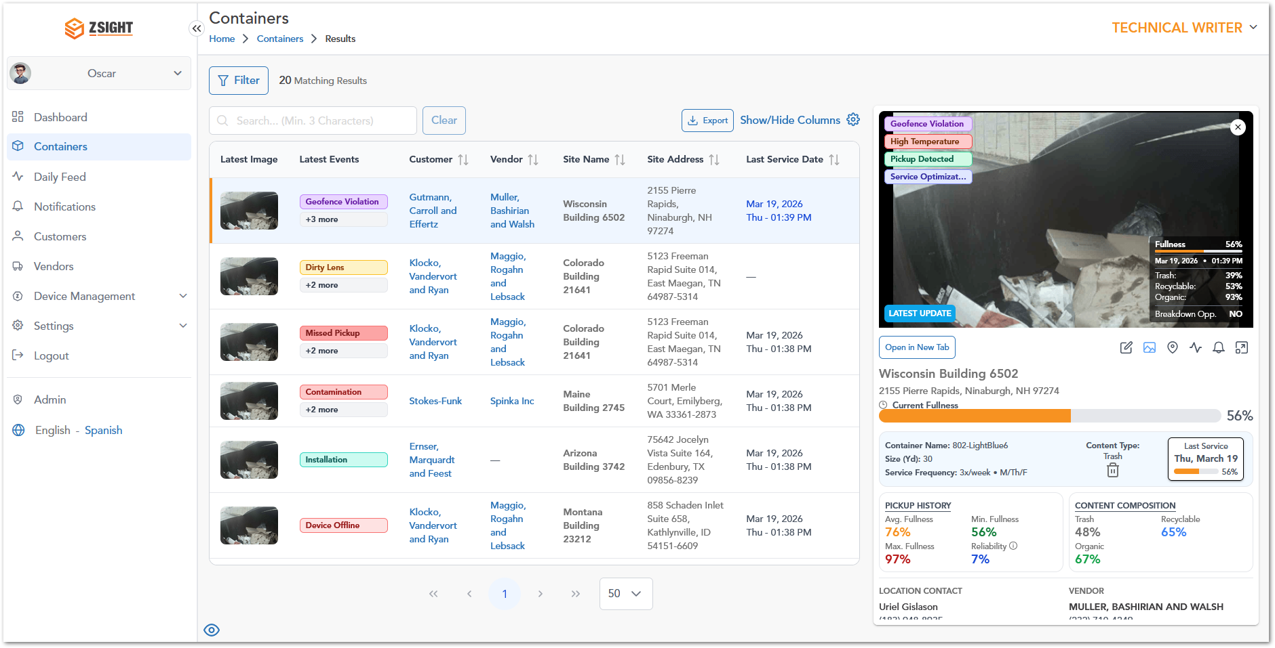

Container Details – Full View
By selecting Open in New Tab, the system opens the Container Details in a dedicated page. When scrolling down in the Container Details Full View, users can access additional operational and analytical information related to the container. This section provides deeper insights into device data, service performance, and optimization opportunities.
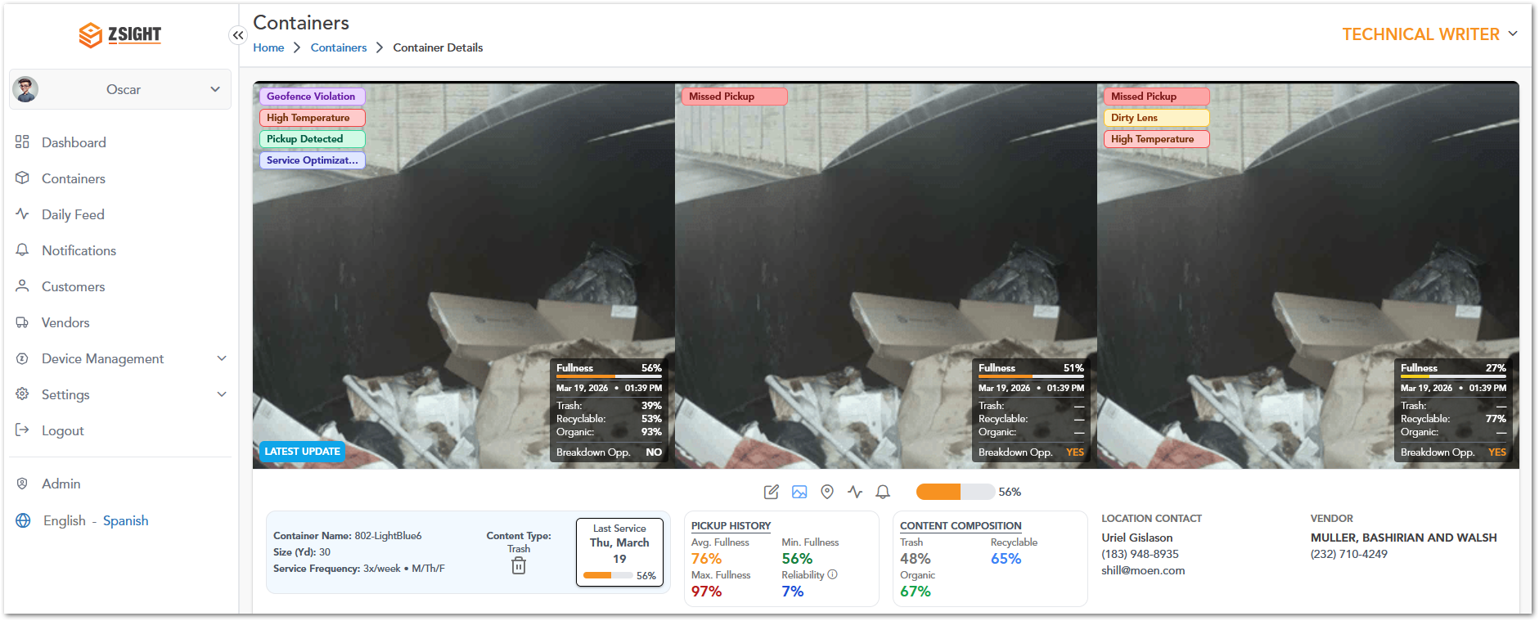
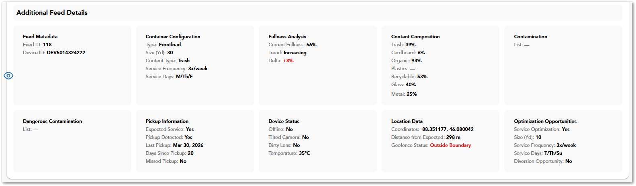
Sections Included
- Feed Metadata: Displays identification details such as Feed ID and Device ID associated with the container.
- Container Configuration: Provides configuration details including container type, size, content type, and scheduled service frequency and days.
- Fullness Analysis: Shows current fullness percentage, trend (e.g., increasing or decreasing), and variation over time.
- Content Composition: Breaks down the detected waste types (e.g., trash, recyclable, organic, glass, metal) with corresponding percentages.
- Contamination: Lists any detected contamination within the container (if applicable).
- Dangerous Contamination: Highlights any hazardous materials detected that may require special handling.
- Pickup Information: Includes service-related data such as expected service status, pickup detection, last pickup date, days since last pickup, and missed pickup indicators.
- Device Status: Displays operational status of the device, including connectivity, camera position, lens condition, and temperature.
- Location Data: Provides geolocation details such as coordinates, distance from expected location, and geofence status.
- Optimization Opportunities: Suggests potential improvements such as service optimization, recommended container size, service frequency, and diversion opportunities.

Container Details – Full View Menu
In the Container Details – Full View, users can access additional actions and views through a sub-menu located below the image section. To access these options:
- Navigate to the Containers module.
- Select a container to open the Container Details – Full View (using Open in New Tab).
- Locate the sub-menu bar positioned below the container images.
- Click on any of the available icons to switch between views or perform actions.
Name | Preview | Description
Edit container |  | Allows the user to modify container configuration details such as ID, type, size, content type and service settings.
Gallery Mode |  | This is the main page within the full view window for container details.
Map Mode |  | Shows location-related information and spatial context of the container.
Open Daily Feed |  | Redirects the user to the Daily Feed module filtered for the selected container
Open Notifications |  | Redirects the user to the Notifications module filtered for the selected container.
Container Fullness |  | Displays the current fill level of the container using a visual progress indicator.

Container Details – Full View Edit Container
The container edit option allows the user to modify container configuration details such as type, size, and service schedule.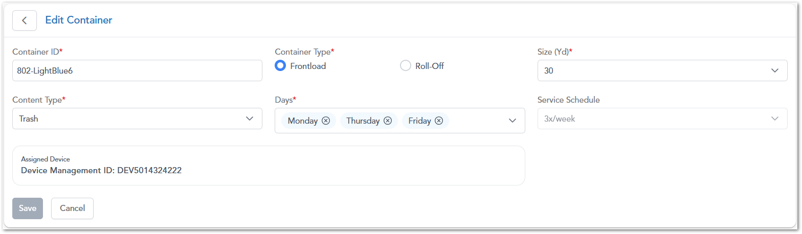

Container Details – Full View Container Location
The Location view displays the geographical position of the container on an interactive map, allowing users to visualize its placement and proximity to surrounding areas.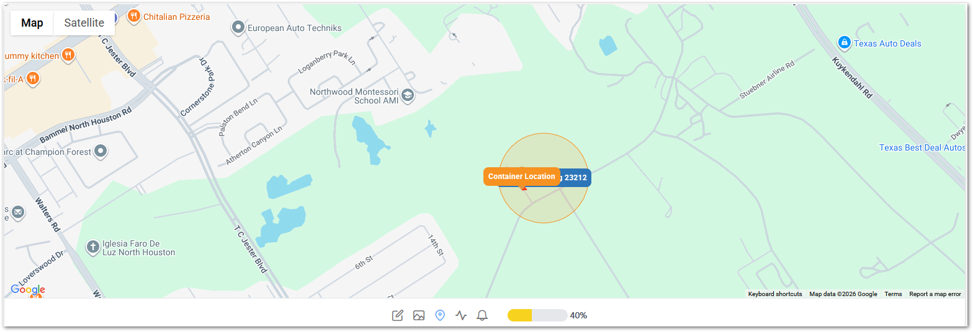

Daily Feed
The Daily Feed displays a chronological stream of images and events captured from containers, allowing users to review recent activity and monitor changes in container status over time. The module presents information using a table structure similar to the Containers module, as it reflects the operational status of containers for a given day. Additionally, it includes extra fields related to the type of content being collected, providing more context for daily operations.
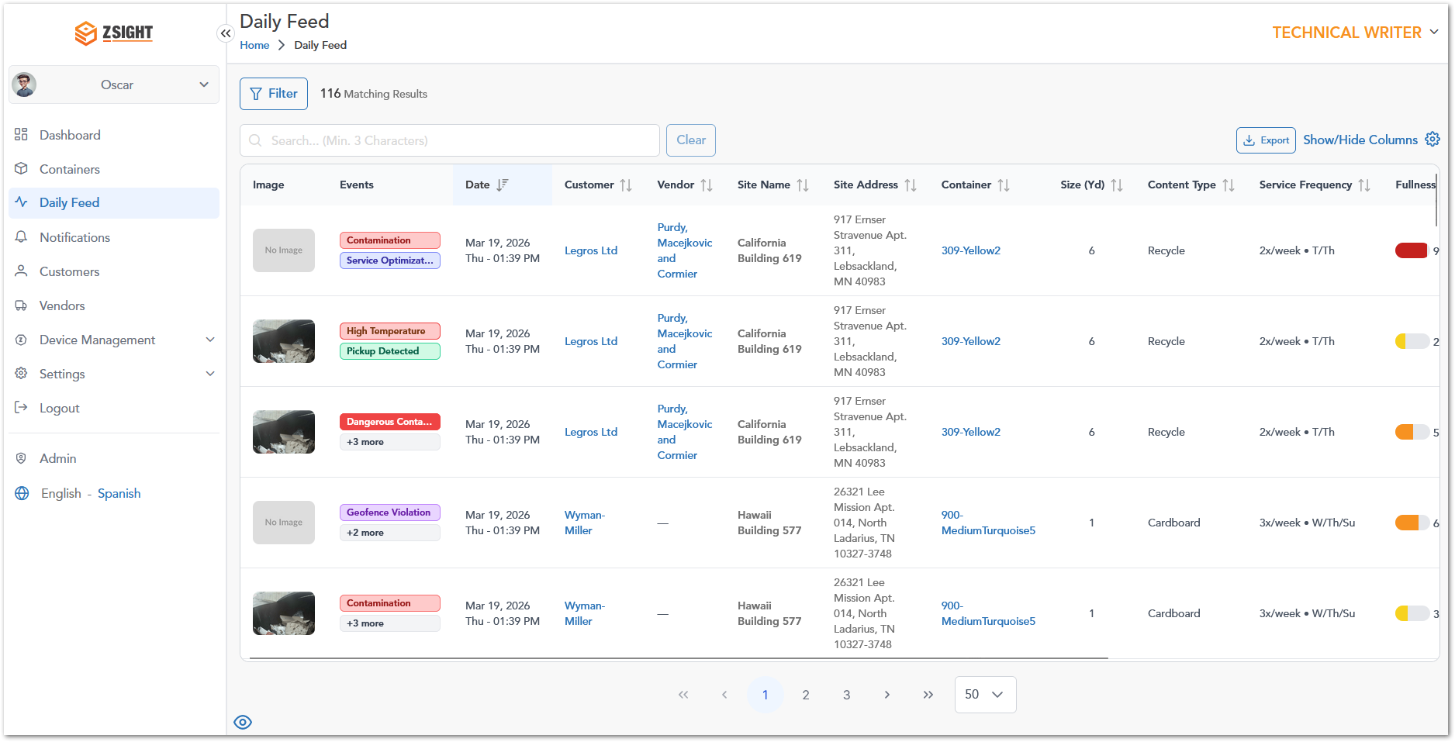

Daily Feed Extra Column Description
Name | Preview | Description
Trash |  | Indicates the % of general (non-recyclable) waste detected inside the container.
Organic |  | Indicates the % of organic waste (e.g., food or biodegradables) inside the container.
Recyclable |  | Indicates the overall % of recyclable materials detected inside the container.
Cardboard |  | Indicates the % of recyclable cardboard material detected inside the container.
Plastics |  | Indicates the % of recyclable plastic waste detected inside the container.
Glass |  | Indicates the % of recyclable glass material detected inside the container.
Metal |  | Indicates the % of recyclable metal waste detected inside the container.

Notifications
The Notifications module provides a centralized view of system-generated alerts related to containers, devices, and operational events. It allows users to track issues, monitor their status, and review their lifecycle from detection to resolution.
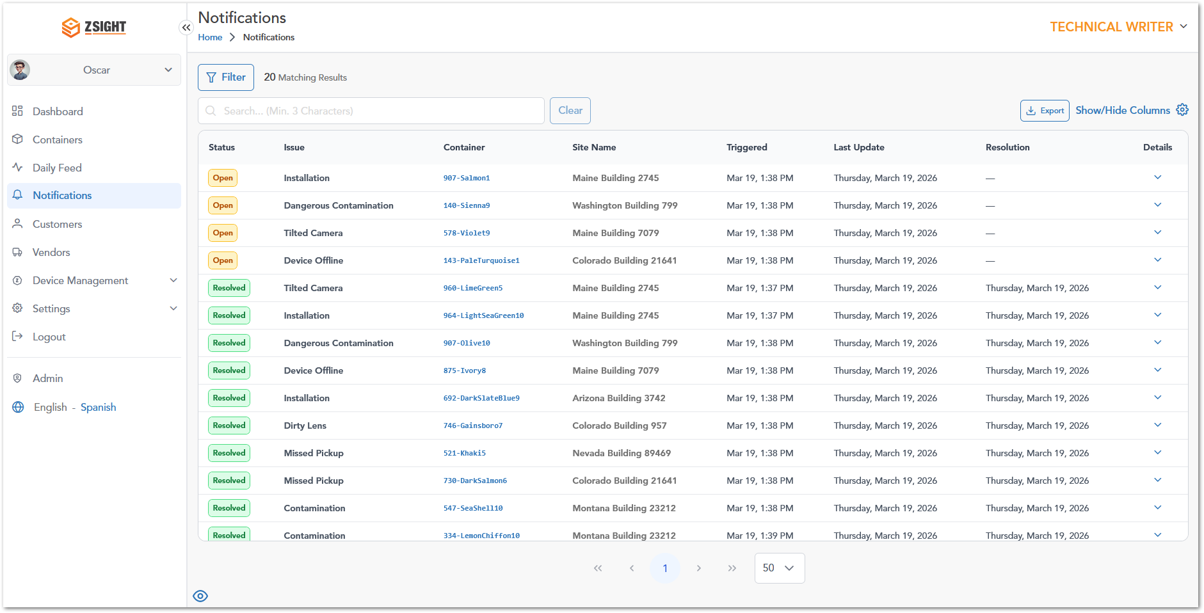

Notifications Column Description
Name | Preview | Description
Status | 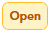  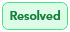 | Current state of the notification:  - Open: Indicates that the issue is active and requires attention.  - Resolved: Indicates that the issue has been addressed and closed.
Issue | Installation | Type of event or problem detected (e.g., contamination, device offline).
Container | 907-Salmon1 | Identifier of the container associated with the notification.
Site Name | Maine Building 2745 | Location where the container is installed.
Triggered | Mar 19, 1:38 PM | Date and time when the notification was generated.
Last Update | Thursday, March 19, 2026 | Most recent update related to the notification.
Resolution | Thursday, March 19, 2026 | Date when the issue was resolved (only resolved issues have dates).
Details | Koepp-Hahn | Expandable option to view additional information.

Notifications – Open Issue Details
When an Open notification is expanded, the system displays detailed information about the active issue, including the number of days since it was triggered and any related events. It also provides Linked Feed Records, which represent the sequence of events captured in the Daily Feed that led to the alert. These records include timestamps, fullness indicators, and event labels (e.g., trigger), allowing users to understand the context, progression, and current state of the issue.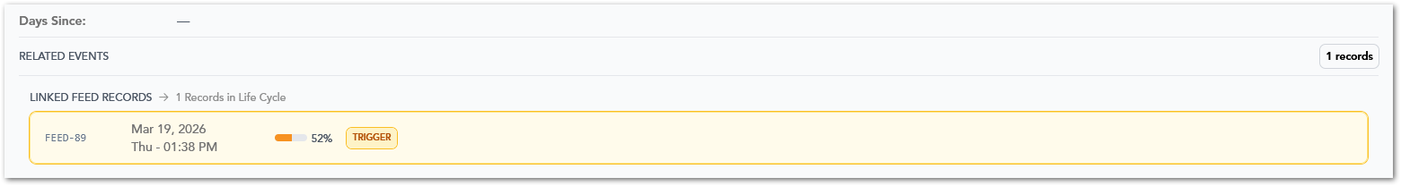

Notifications – Resolved Issue Details
When a Resolved notification is expanded, the system displays detailed information about the issue, including device-related data (such as intended and actual device serial numbers), installation details, and the total number of days since the issue was triggered. It also includes Linked Feed Records, which show the full lifecycle of events associated with the issue—from the initial trigger to its resolution. These records include timestamps, fullness indicators, and event labels (e.g., trigger and resolution), allowing users to understand how the issue progressed and when it was successfully resolved.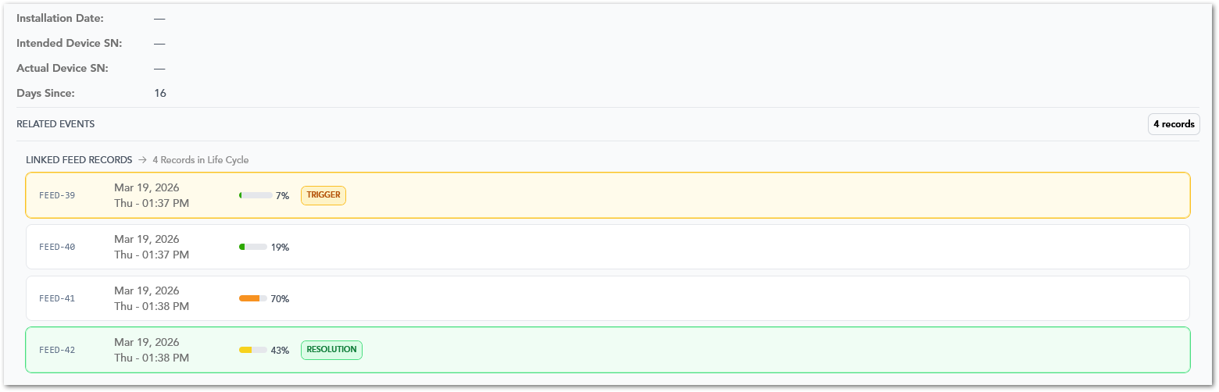

Customers
The Customers module provides a centralized view of all customers managed within the system, allowing users to access, monitor, and maintain customer-related information. From this module, users can review key operational data such as service locations, assigned containers, contact details, account ownership, and customer status.
It also enables efficient data management through search, filtering, sorting, column customization, and export functionalities, supporting both day-to-day operations and reporting needs.

Customers Column Description
Name | Description
Customer Name | Displays the name of the customer; clickable to access detailed customer information.
Customer ID | Unique identifier assigned to each customer in the system.
Service Locations | Indicates the number of service locations associated with the customer.
Containers | Shows the total number of containers assigned to the customer.
Contact Name | Name of the primary contact for the customer account.
Contact Phone Number | Phone number of the primary contact.
Contact Email | Email address of the primary contact.
Account Manager | Account manager responsible for managing the customer account.
Date Added | Date when the customer was created in the system.
Status | Indicates whether the customer is active or inactive.
Actions | Provides available actions for the record, such as editing the customer.

Vendors
The Vendors module provides a centralized view of all service providers associated with the system, allowing users to manage vendor-related information and monitor their operational involvement. From this module, users can review key details such as vendor contact information, service coverage, associated containers, and optimization activity.
It also supports efficient data management through search, sorting, column customization, and export functionalities, enabling users to easily access and maintain vendor records.

Vendors Column Description
Name | Description
Vendor Name | Displays the name of the vendor; clickable to access detailed vendor information.
Vendor ID | Unique identifier assigned to each vendor in the system.
Address | Physical address associated with the vendor.
Contact Phone Number | Phone number of the vendor’s primary contact.
Contact Email | Email address of the vendor’s primary contact.
# Containers | Indicates the number of containers associated with the vendor.
# Service Optimization | Shows the number of service optimization instances related to the vendor.
Actions | Provides available actions for the record, such as editing the vendor.

Device Management
The Device Management module allows users to manage cameras and hardware installed in containers. It includes device status, configuration, and maintenance-related information.

Devices
This section provides a centralized view of all devices installed in containers, allowing users to monitor and manage hardware associated with the system. It enables users to track device assignments, review container associations, and access key operational details such as container size, content type, service frequency, and location.
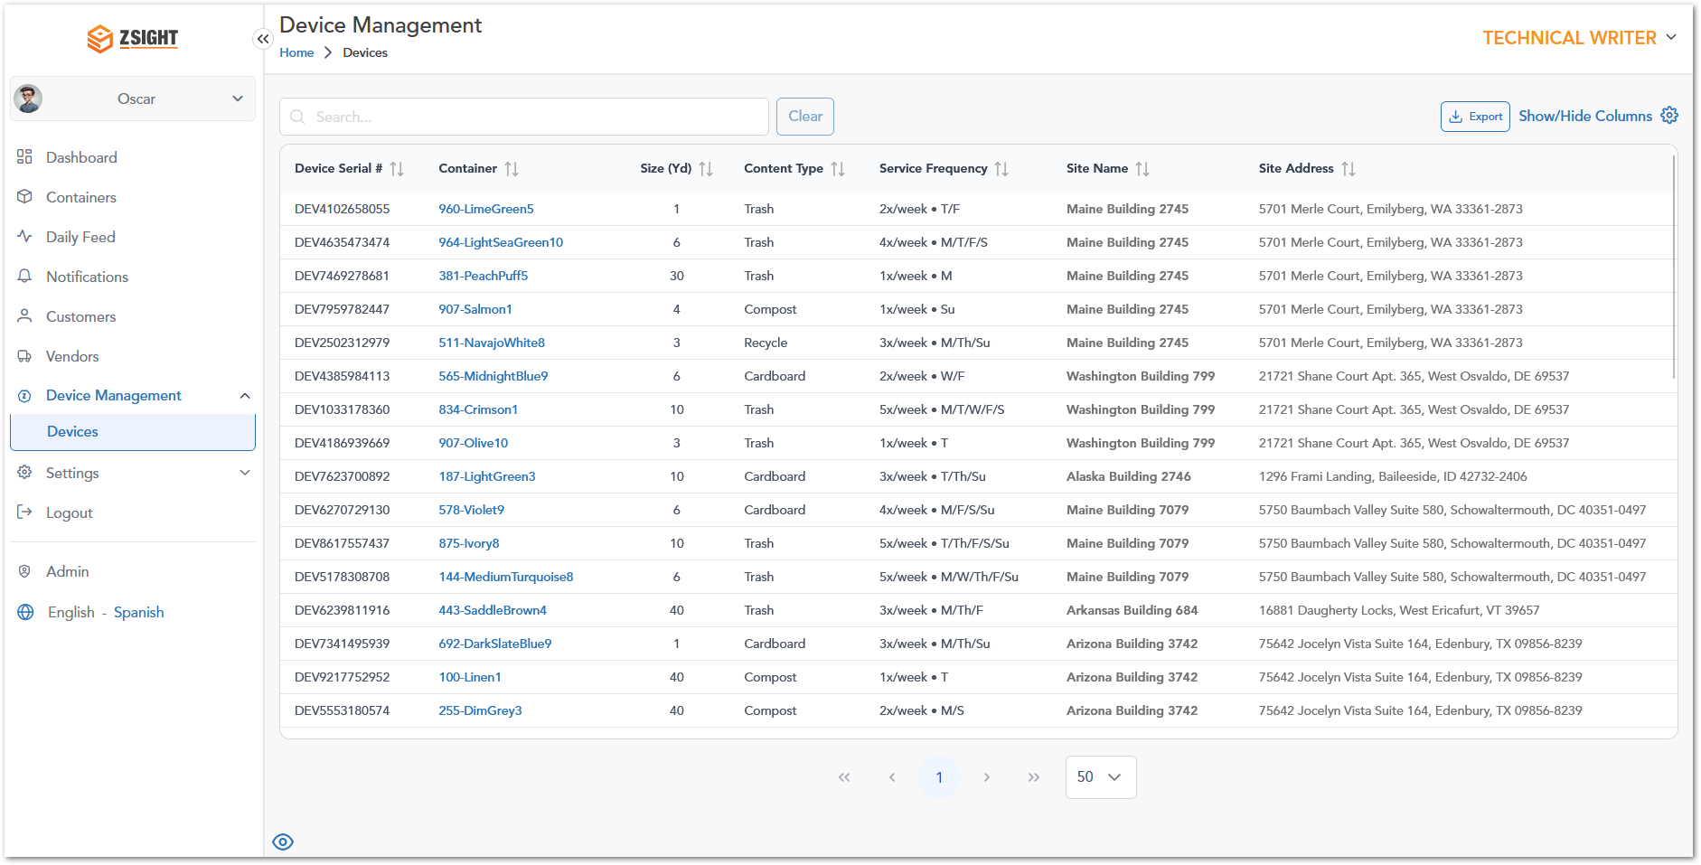

Settings
The Settings module allows users to manage personal preferences, account configurations, and team-related information within the system. It provides access to profile details, account settings, and user management functionalities, ensuring that users can maintain accurate information and control their working environment.

My Profile
The My Profile section allows users to view and update their personal information and preferences within the system. It enables users to maintain accurate contact details, manage login credentials, and configure language and timezone settings.
Name | Description
First Name | User’s first name.
Last Name | User’s last name.
Email | User’s registered email address used for login.
Preferred Language | Language preference for the application interface.
Password | Allows the user to update their account password.
Confirm Password | Field to confirm the new password entered.
Voice Number | User’s primary contact phone number.
SMS Text Number | Phone number used for receiving SMS notifications.

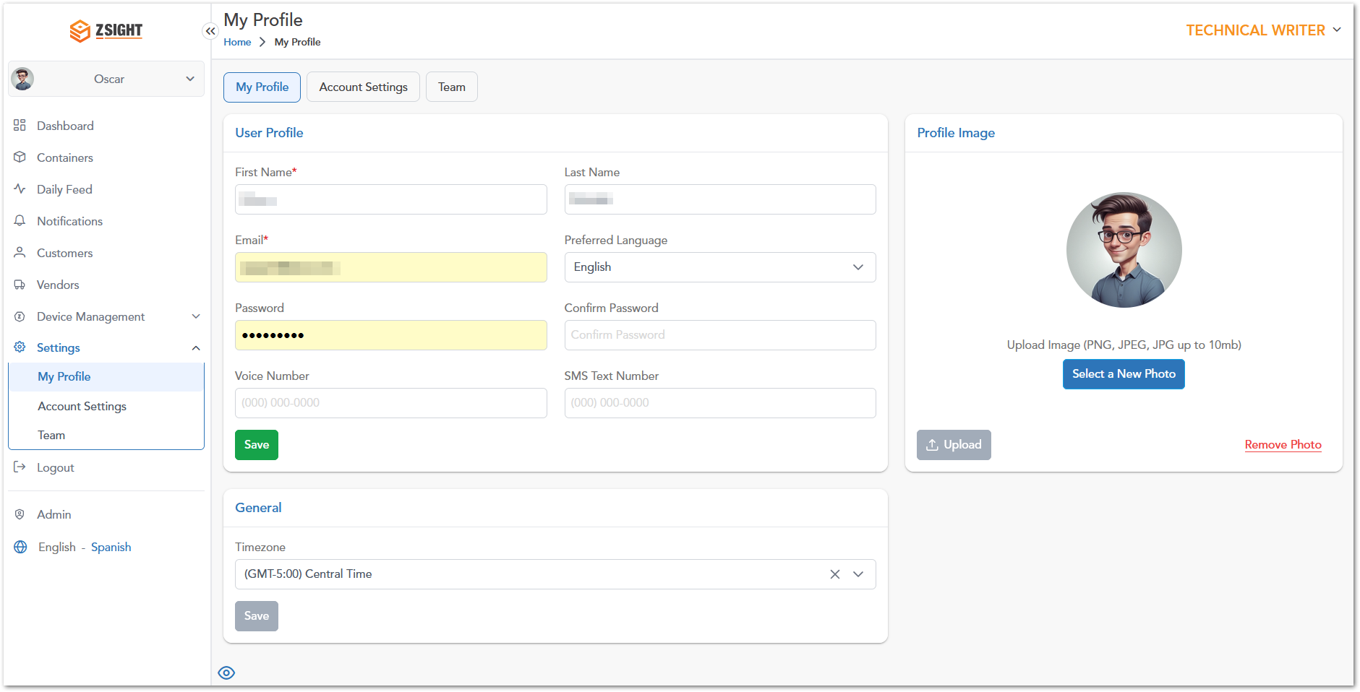

Account Settings
The Account Settings section allows users to view and manage account-level information, including general account details, contact management, and communication preferences. This section ensures that account data remains accurate and that users can control how communications are received.
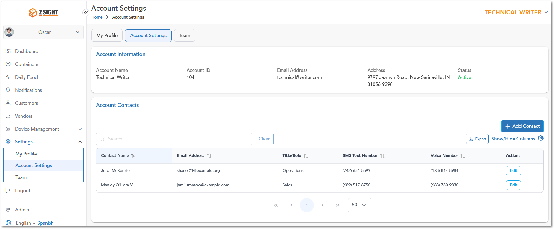

Team
The Team section allows users to view and manage all users associated with the account. It provides visibility into user roles, activity, and access status, enabling effective management of account members and permissions.
Name | Description
User Name | Displays the name of the user associated with the account.
Email | Email address of the user, used for login and communication.
Role | Defines the user’s level of access within the system (e.g., Account Owner, Admin, User).
Registration Date | Date and time when the user was added to the account.
Last Login Date | Most recent date and time the user accessed the system.
Status | Indicates whether the user is active or inactive.
Actions | Provides available options to manage the user (e.g., edit or update access).

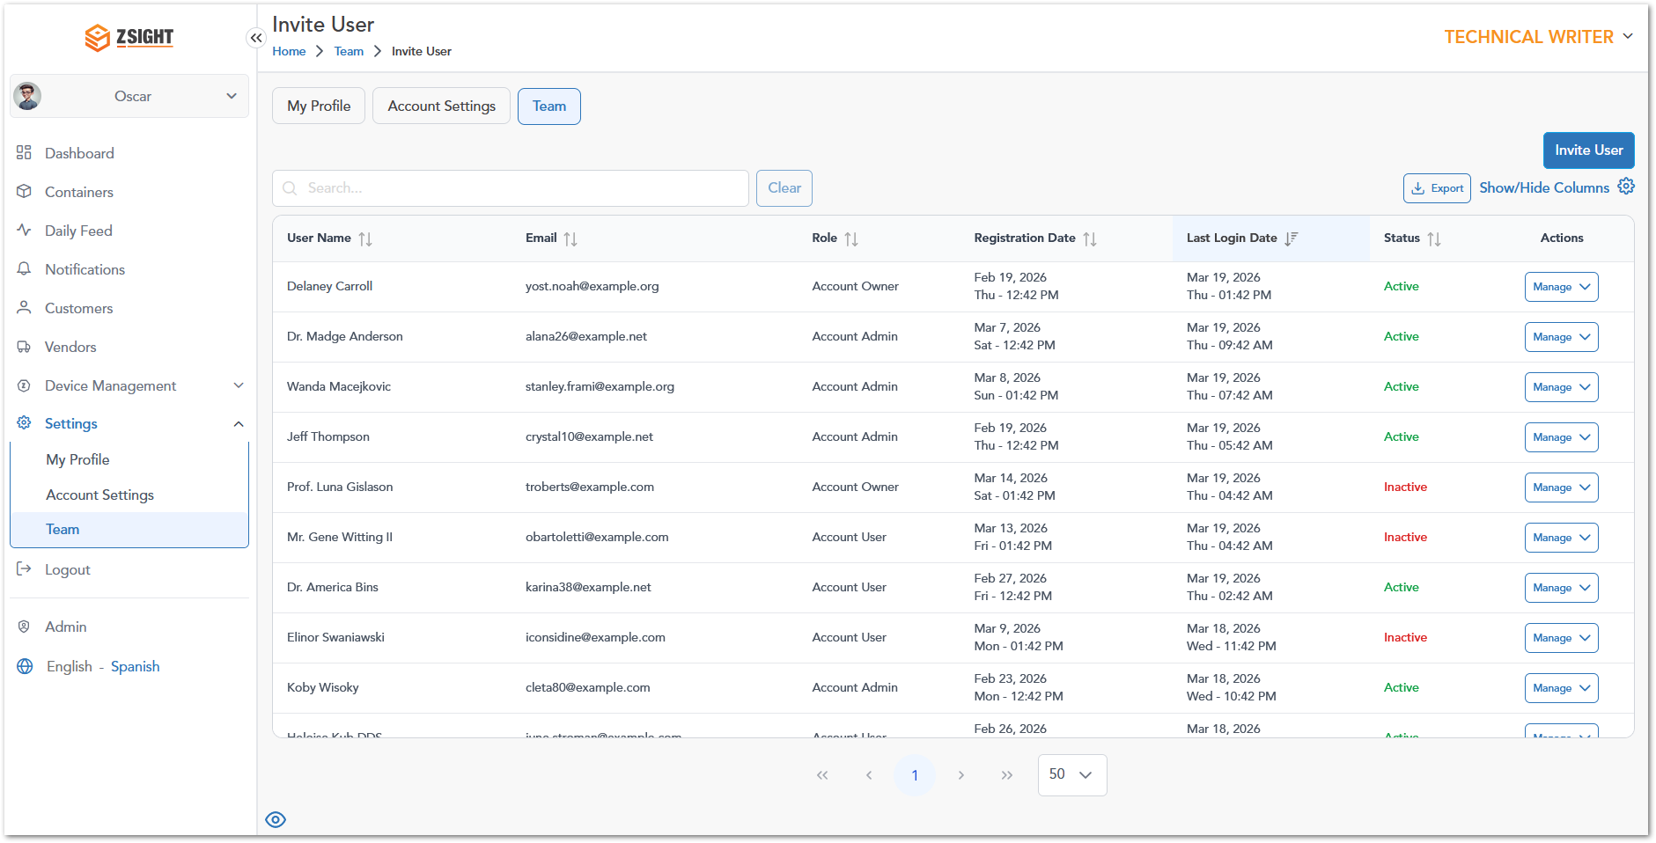

Admin Options
The Admin section provides access to advanced system management features intended for administrative users. It allows centralized control over core system entities such as accounts, users, customers, contracts, subscriptions, inventory, and reporting.
This section is designed to support configuration, monitoring, and maintenance activities across the platform, enabling administrators to manage system data, oversee operations, and ensure proper system governance.

Available modules
The Admin section includes the following modules:
- Admin Dashboard: Provides an overview of system activity and key metrics.
- Accounts: Manages customer accounts and their associated information.
- Customers: Provides access to customer records within the admin scope.
- Users: Allows management of user accounts and permissions.
- Contracts: Handles contract-related data and configurations.
- Subscriptions: Manages subscription plans and service agreements.
- Inventory: Tracks and manages system assets and resources.
- Installers: Manages installer-related information and assignments.
- Reports: Provides access to system-generated reports and analytics.
- Audit Trail: Tracks system activity and changes for traceability.
Note: Access to the Admin section is typically restricted to users with elevated permissions, as it contains system-wide configuration and management functionalities.

Admin Dashboard
The Admin Dashboard provides a high-level overview of system activity and key operational metrics for administrative users. It is intended to offer visibility into overall platform performance and support monitoring and decision-making at a system-wide level.

Accounts
The Accounts module within the Admin section allows administrators to manage all accounts registered in the system. It provides a centralized view of account information, enabling administrators to create, edit, and monitor account-level data.
This module supports system-wide administration by allowing control over account details, status, and access to account-specific dashboards.
Name | Description
Account Name | Displays the name of the account; clickable to access account-specific details.
Account ID | Unique identifier assigned to each account.
Email Address | Primary email associated with the account.
Address | Physical address linked to the account.
Status | Indicates whether the account is active or inactive.
Actions | Provides available actions such as editing the account or accessing its dashboard.

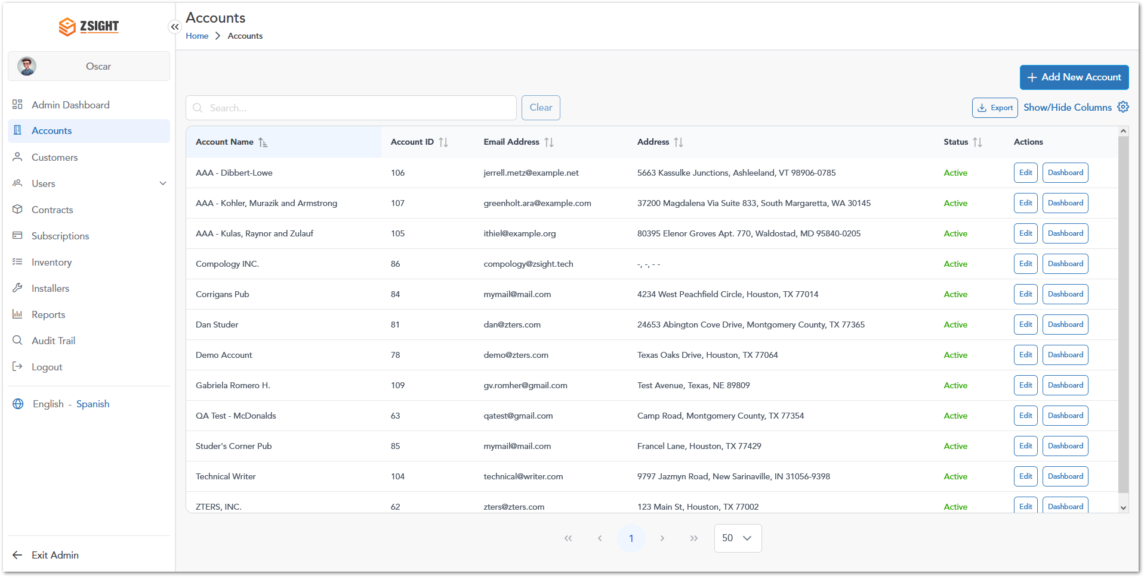

Customers
The Customers module within the Admin section allows administrators to view and manage all customer records across the system. It provides a centralized view of customer information, including account associations and contact details, enabling administrators to maintain accurate data and oversee customer relationships at a system-wide level.
Name | Description
Customer Name | Displays the name of the customer; clickable to access detailed customer information.
Customer ID | Unique identifier assigned to each customer.
Account Name | Indicates the account associated with the customer.
Contact Name | Name of the primary contact for the customer.
Contact Phone Number | Phone number of the primary contact.
Contact Email | Email address of the primary contact.
Actions | Provides available actions such as editing the customer record.

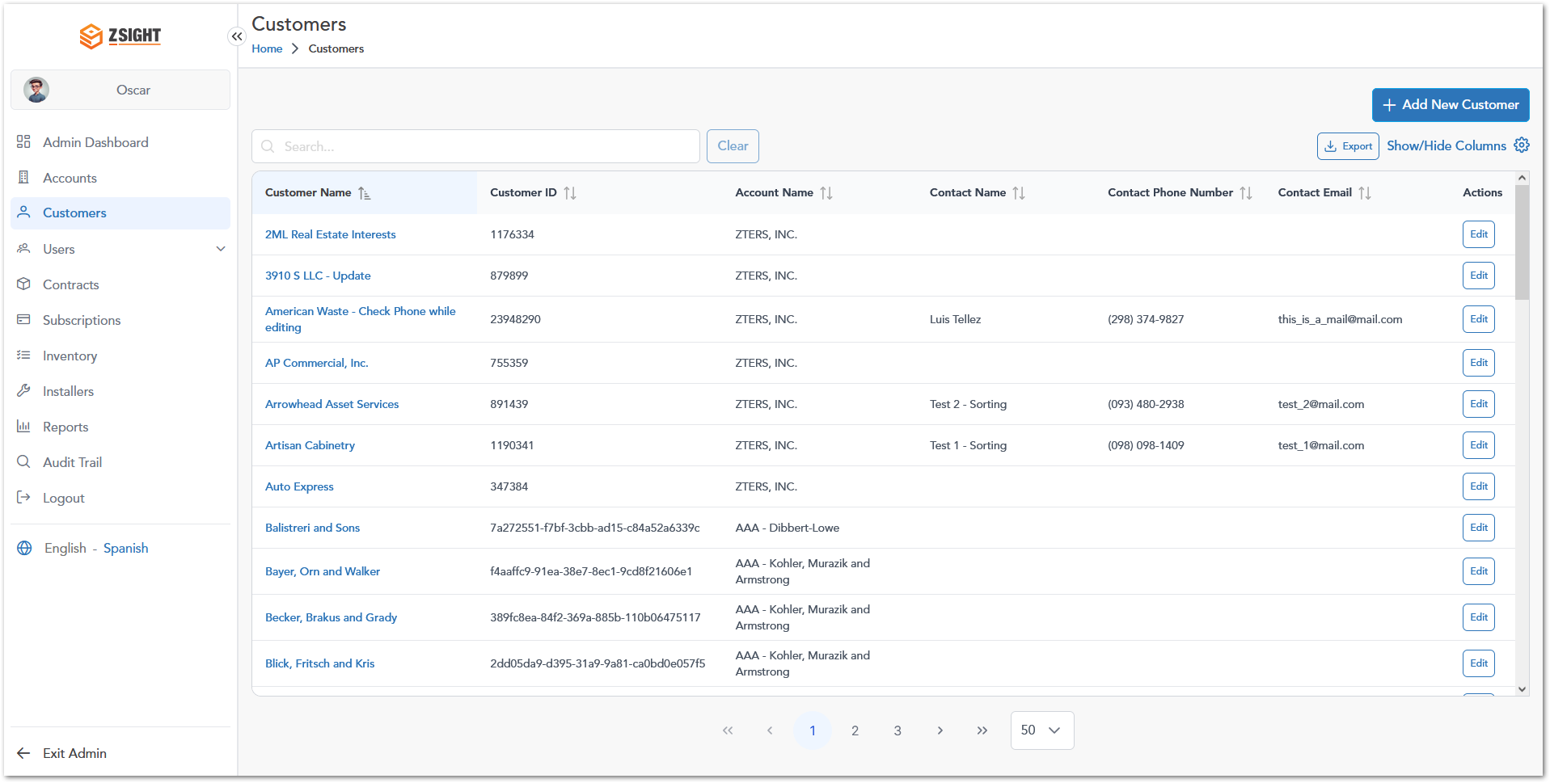

Users
The Users module within the Admin section allows administrators to manage all users across the system. It provides access to both internal users and account-level users, enabling administrators to oversee user access, roles, and system permissions.

Internal Users
The Internal Users section allows administrators to manage users who have internal access to the ZSight platform. These users typically belong to the organization and have roles that define their level of access and permissions within the system.
Name | Description
Name | Displays the full name of the internal user.
Email | Email address associated with the user account.
Role | Defines the user’s role and level of access (e.g., Admin, User).
Registration Date | Date and time when the user was registered in the system.
Last Login Date | Displays the most recent date and time the user accessed the platform.
Status | Indicates the current state of the user account (e.g., Registered).
Actions | Provides available actions such as editing user information.

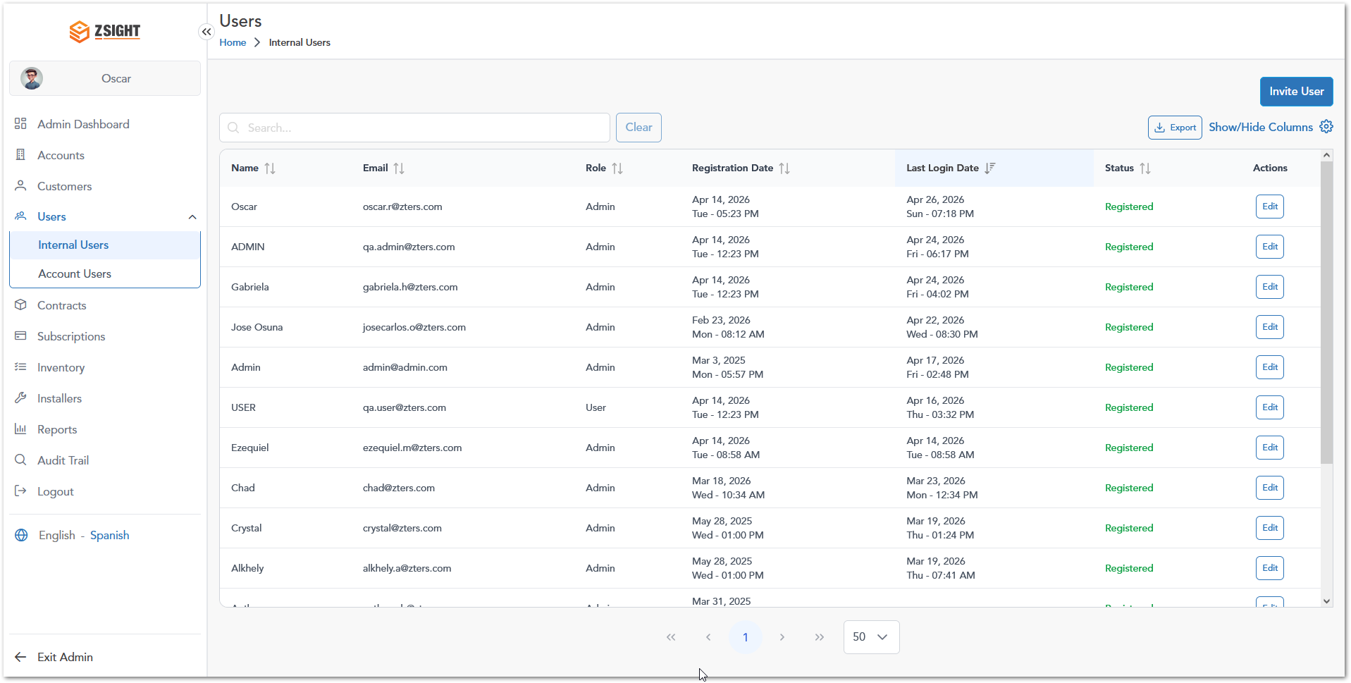

Account Users
The Account Users section allows administrators to manage users associated with one or multiple accounts. These users have roles defined per account, enabling flexible access control across different customer accounts within the system.
Name | Description
Name | Displays the full name of the user.
Email | Email address associated with the user account.
Account & Role | Shows the accounts the user is associated with and their role in each account (e.g., Account Admin, Account Owner, Account User).
Registration Date | Date and time when the user was registered in the system.
Last Login Date | Displays the most recent date and time the user accessed the platform.
Status | Indicates the current state of the user account (e.g., Registered).
Actions | Provides available actions such as editing user details.

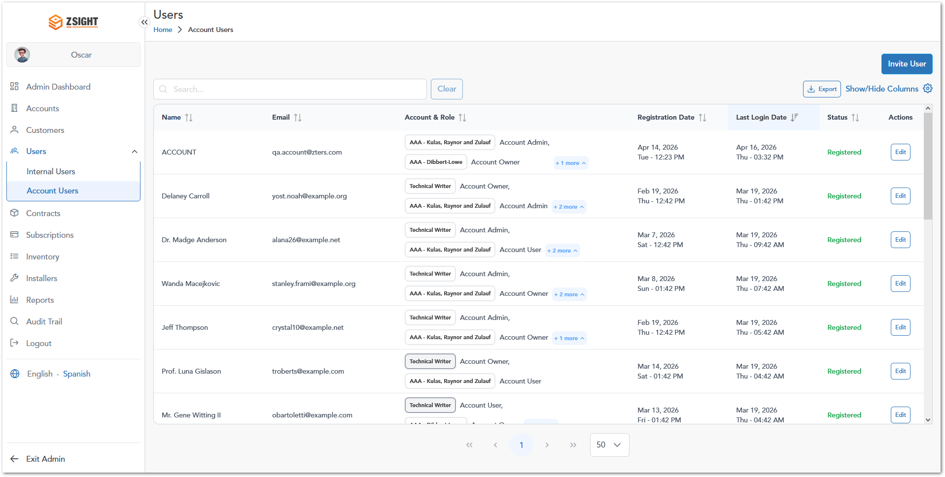

Contracts
The Contracts module is intended to manage contractual agreements between accounts, customers, and service providers. It will provide visibility into contract terms, durations, and service conditions to support operational and billing processes.

Subscriptions
The Subscriptions module is designed to manage service plans and recurring service agreements associated with accounts or customers. It will enable tracking of subscription details, service frequency, and active service configurations.

Inventory
The Inventory module is intended to manage and track system assets, including containers, devices, and related equipment. It will provide visibility into asset availability, allocation, and lifecycle status.

Installers
The Installers module is designed to manage installer personnel or teams responsible for deploying and maintaining devices and containers. It will support assignment tracking and coordination of installation activities.

Reports
The Reports module is intended to provide access to system-generated reports and analytics. It will allow users to review operational data, monitor performance, and support decision-making through structured insights.

Audit Trail
The Audit Trail module provides a record of system activity, allowing administrators to track changes made across the platform. It is intended to support traceability, accountability, and monitoring by capturing details about actions performed on system entities.
Name | Description
Account | Displays the account associated with the action performed.
Entity | Indicates the type of entity that was modified (e.g., Customer, Container, User).
Entity ID | Unique identifier of the affected entity.
Action | Describes the type of action performed (e.g., Create, Update, Delete).
Changed From | Shows the previous value before the change was made.
Changed To | Displays the new value after the change.
Changed By | Identifies the user who performed the action.
Date & Time | Indicates when the action occurred.

Info: This module is intended for auditing and monitoring purposes and is typically used to review historical changes and investigate system activity.

Overall System Functionalities
The Overall System Functionalities section describes common features available across multiple modules within the ZSight application. These functionalities provide users with tools to efficiently navigate, filter, search, and manage data within tables and system views.
The following subsections outline the key shared features that enhance usability and data interaction throughout the platform.

Filter
The Filter functionality allows users to refine the data displayed in tables by applying specific criteria. It is available across multiple modules and helps users quickly locate relevant records based on different attributes such as customer, vendor, location, container details, and service information.

How it works
The filter panel provides a set of fields that users can use to narrow down results. These fields may include dropdown selectors, search inputs, and range sliders (e.g., fullness percentage or last service date). Once the desired criteria are selected, users can apply the filter to update the table results dynamically.
Note: The available filter options may vary depending on the module. Each module displays only the filters relevant to its corresponding table columns and data structure.

Search
The Search functionality allows users to quickly locate records within a table by entering keywords. The search is applied dynamically and filters the displayed results based on matching values.
Info: A minimum of 3 characters is required to perform a search.

Export
The Export functionality allows users to download the data displayed in a table as an Excel file. This feature is useful for offline analysis, reporting, or data sharing.

How it works
By clicking the Export button, the system generates and downloads an Excel file containing the records and columns currently available in the table.
Info: The exports are limited to a maximum of 5,000 records per file.

Show/Hide Columns
The Show/Hide Columns functionality allows users to customize the visibility of table columns within each module. Users can choose which columns to display based on their preferences or specific data needs.

How it works
By clicking the Show/Hide Columns option, a panel is displayed listing all available columns for the current module. Users can:
- Select (check) a column to make it visible
- Deselect (uncheck) a column to hide it
- Reorder columns by dragging them into the desired position
Info: The available columns may vary depending on the module, as each table contains different data fields.

User Roles
Role assignation for the application users. It could be presented in a table as follows:
Description | User 1 | User 2 | Admin User
Access to the invoice summary interface 1 | 
Access to the invoice summary interface 2
Access to the invoice summary interface 3

Note: This section is mandatory for all applications with role-based access.

WORKING PROCEDURES
Workflows (including diagrams if applicable) for different options within the application.

Working Procedure 1
Working Procedure 1 (e.g. “Create invoice…”)

Working Procedure 2
Working Procedure 2. (e.g. “Approve request…”)

Working Procedure 3
Working Procedure 2. (e.g. “Generate Report…”)

APPROVAL SIGNATURES
Digital signature blocks below are formatted for DocuSign / Adobe Sign.
Name | Role | Digital Signature Block | Date (dd/mm/aa)
Anthony Bures | Digital Development Manager |  | 30/04/2026

--- END OF THE DOCUMENT ---

